**EMPLOYEE MANAGEMENT SYSTEM**

By

Richard Wambogo

SCNI/01300/2021

A Project Proposal Submitted to fulfil the requirements for Completion of the IBL 1 , School of Computing and Information Technology.

Bachelors of Technology in Communication and Computer Networking

**Technical University of Kenya**

June 2023

# Pager

In East Africa's rapidly growing IT industry, efficient management of human capital is crucial for SMEs looking to establish themselves as regional brands. Implementing an Employee Management System (EMS) provides a solution to this challenge, streamlining HR processes and enabling growth.

As the SME expands its operations in East Africa, managing a rapidly growing workforce becomes increasingly challenging. Manual systems like paper-based processes and fragmented spreadsheets prove inadequate, leading to inefficiencies, errors, and delays. The EMS automates personnel-related processes, eliminating paperwork and reducing risks.

The EMS offers a comprehensive, user-friendly platform that streamlines employee management processes. It digitizes and centralizes employee data, minimizing errors and inefficiencies. Key features include employee onboarding, attendance tracking, leave management, performance evaluations, payroll processing, and compliance management.

By implementing the EMS, the SME can allocate resources strategically, enabling HR teams to focus on strategic initiatives rather than administrative tasks. Real-time access to HR data and analytics enhances decision-making capabilities for managers. Accurate record-keeping and compliance reporting ensure long-term sustainability and growth.

The implementation of an Employee Management System presents a transformative opportunity for the fast-growing SME in East Africa's IT industry. Overcoming the challenges of workforce expansion and regulatory complexities, the EMS streamlines HR processes, fosters a positive work environment, and supports the SME's vision of becoming a regional brand. By unlocking the potential of its talented workforce, the SME can maximize operational efficiency and achieve success in the rapidly evolving East African market.

# Methodology

Given the time constraint of one month and a small business with 60 personnel, a suitable software engineering methodology for the design and implementation of the Employee Management System (EMS) could be the Rapid Application Development (RAD) methodology. RAD emphasizes rapid prototyping and iterative development, which can help expedite the project while ensuring stakeholders' involvement and feedback.

# RAD Methodology guidelines / Objectives

1. Fact finding and analysis of data gathered via careful users and stakeholders involvement.
2. Project design using design tools and methods
3. Breaking down the project in smaller modules and iteration development.
4. Prototyping of various modules and eventually the whole system.
5. Deployment of the new system.
6. Training, testing and Maintenance

# Specific objectives of the EMS system

1. To enhance the efficiency in managing employee records and data
2. To manage and track the employee attendance database.
3. To allow for seamless integration of employees and give room for scalability
4. To automate the payroll system.

# Design

1. Context UML of the EMS.

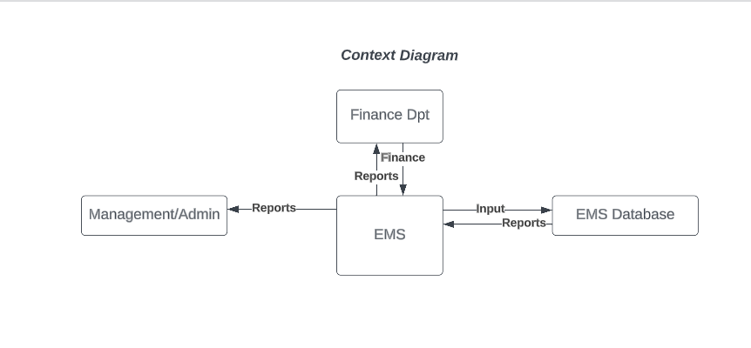

1. Interactional UML

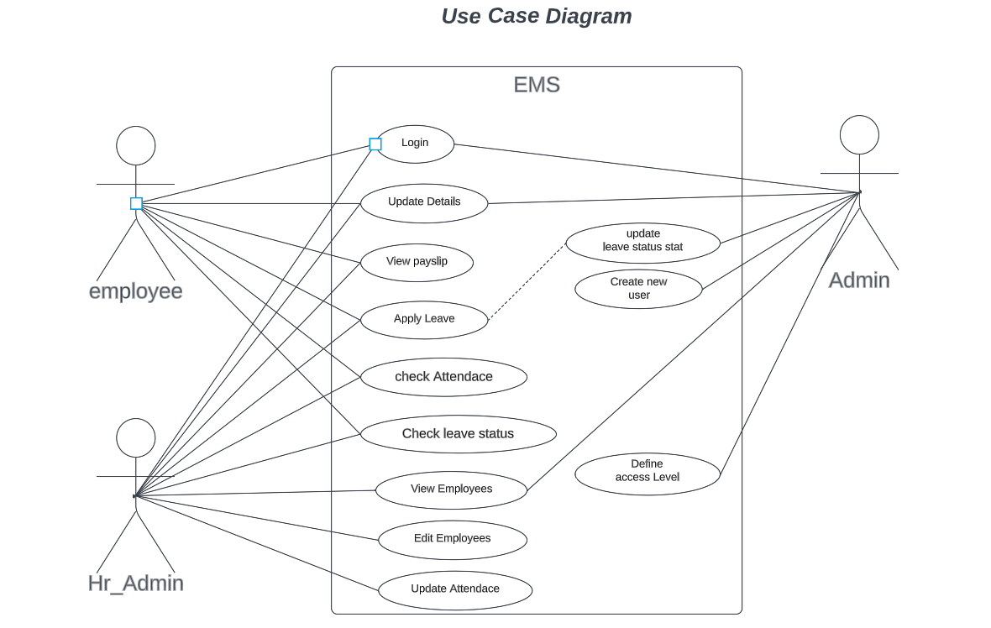

1. Structural UML

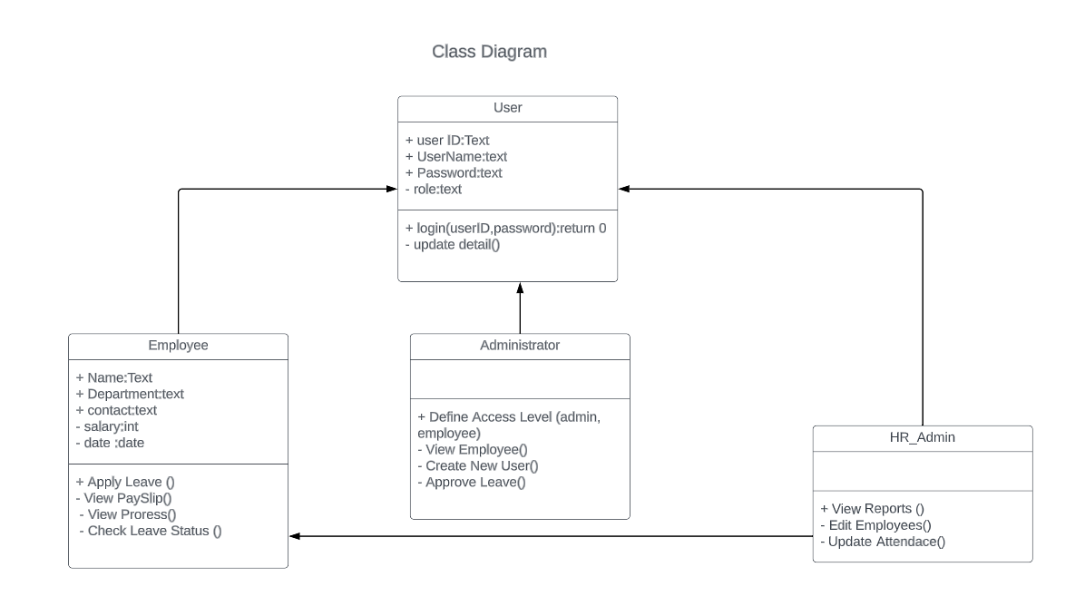

1. Behavioural UML

